Agnes Corpuz and Prince Merluza

Genesys | manila, philippines

PureCloud Embedded Framework

Version 1.0 | October 15, 2018

# Integration Points

## Dynamic Configuration

This sample contains dynamic setting of the framework.js configuration items.

* **/public/framework.js** - Contains modified framework.js file from [PureCloud Embeddable Framework example](https://developer.mypurecloud.com/api/embeddable-framework/purecloud-embeddable-framework-example.html). This file will get dynamic values from URL parameters.
* **/app/templates/application.hbs** - HTML template for the web app. Includes the embedded iframe for the softphone. The 'src' attribute is dynamically generated from data stored in the localStorage. This value could also be generated server side or by any means where the iframe's property can be modified.
* **/app/components/framework-config.js** - Contains the actions for events when the user changes any settings in the configuration page. This calls the service framework-config which handles the actual logic of storing and updating the values to the browser's localStorage.
* **/app/services/framework-config.js** - Contains the logic behind saving/loading the configuration values to and from the localStorage. In production, this is recommended to be put into a proper backend storage/database.

## screenPop

When there is an incoming interaction, the PEF_SearchValue and PEF_URLPop attributes would determine which page the user will be redirected to.

* **/public/framework.js** - screenPop method should be included in this file.
* **/app/components/windows-event-listener.js** - This file contains the implementation of the screenPop method.

## addCustomAttributes

* **/public/framework.js** - addCustomAttributes method should be included in the window.addEventListener of this file.
* **/app/components/contact/contact-details.js** - This file contains the implementation of the addCustomAttributes method.

## addAssociation

* **/public/framework.js** - addAssociation method should be included in the window.addEventListener of this file.
* **/app/components/contact/contact-details.js** - This file contains the implementation of the addAssociation method.

## clickToDial

* **/public/framework.js** - clickToDial method should be included in the window.addEventListener of this file.
* **/app/components/phone-number.js** - This file contains the implementation of the clickToDial method.

## contactSearch

* **/public/framework.js** - contactSearch method should be included in this file.
* **/app/components/windows-event-listener.js** - This file contains the implementation of the contactSearch method. As an example, Weather Line is added as an external contact for this application.

## addTransferContext

* **/public/framework.js** - addTransferContext method should be included in the window.addEventListener of this file.
* **/app/components/windows-event-listener.js** - This file contains the implementation of the addTransferContext method.

## processCallLog

* **/public/framework.js** - processCallLog method should be included in this file.
* **/app/components/windows-event-listener.js** - This file contains the implementation of the processCallLog method.

## updateStatus

* **/public/framework.js** - updateStatus method should be included in the window.addEventListener of this file.
* **/app/controllers/application.js** - This file contains the implementation of the updateStatus method.

## getTranscript

* **/public/framework.js** - getTranscript method should be included in the window.addEventListener of this file.
* **/app/components/windows-event-listener.js** - This file contains the implementation of the getTranscript method.

# Pages

## Home Page

The home page displays Embedded Framework Methods used in this sample app. This page will be displayed upon page load. This page can be accessed by clicking the Genesys logo or the home icon from the sidebar.

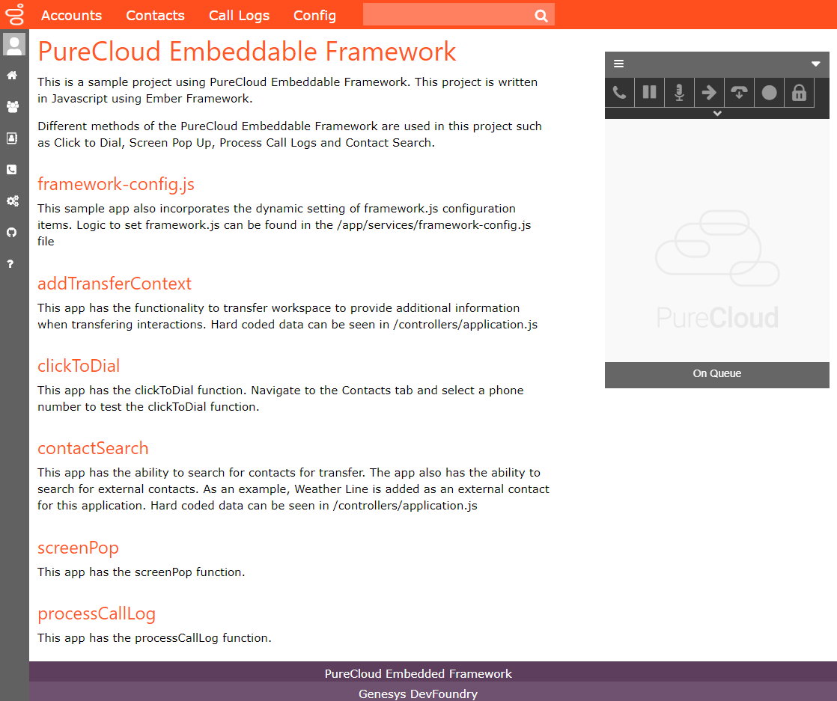

## Accounts Page

The Accounts page displays a list of accounts. When the user clicks on an account, the page will display the account details such as office, address and phone number. When the user clicks the View Contacts link, the app will redirect the user to the Contacts Page showing only the contacts of the specific account.

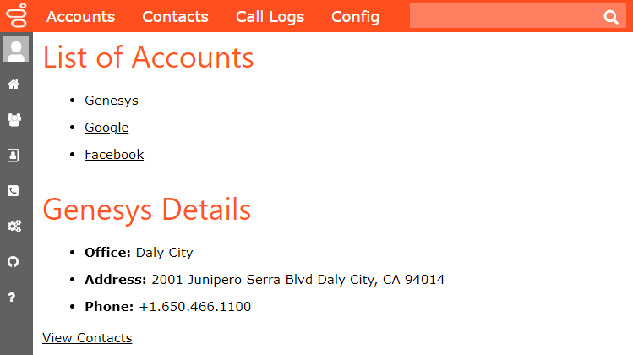

## Contacts Page

The Contacts page displays a list of all contacts in the CRM. When the user clicks the View Contacts link from the Accounts page, this page will be filtered to show only the contacts under the Account. When the user clicks on a name, the app will redirect the user to the contact details page. When the user clicks on an account, the app will redirect the user to the Accounts page. When the user clicks on a phone number, the clickToDial function of the Embedded Framework will be triggered allowing the user to call the contact.

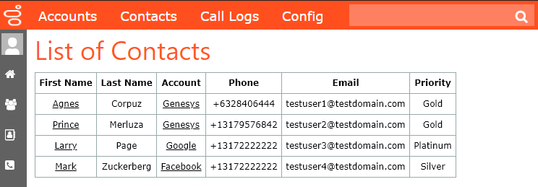

## Contact Details Page

The Contact Details page displays the name, account, phone number, email and priority of a contact. This page can be accessed by clicking a name in the Contacts page. The user will be redirected to this page when an incoming interaction is coming from a contact in the CRM. When the user clicks on the Back to Contacts link, the app will redirect the user back to the Contacts page.

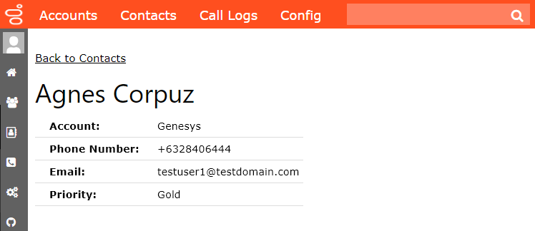

## Call Logs Page

The Call Logs page displays call logs and chat logs details of each conversation. The Call Logs section displays details coming from the processCallLog method of the Embedded Framework. The Chat Logs section displays details coming from the getTranscript method of the Embedded Framework.

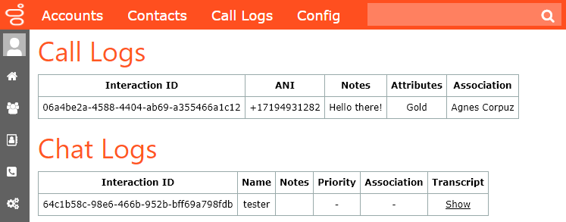

## Config Page

The Config page allows the user to set dynamic configuration settings for the Embedded Framework such as embedWebRTCByDefault, enableCallLogs, dedicatedLoginWindow, theme, customInteractionAttributes and getUserLanguage.

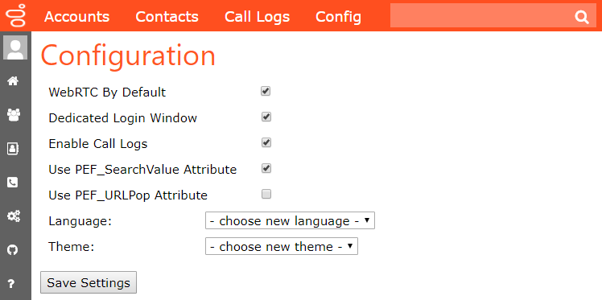

# Embedded Framework Methods

## screenPop

Once there is an incoming interaction in the app, there are two attribute that could change which page the agent is on: (1) PEF_SearchValue and (2) PEF_URLPop.

With PEF_SearchValue, any information could be passed to the search function of the CRM for the screen to show the Contacts search results. If there’s only one result, the screen will redirect to the contact page of the caller displaying the name, account, phone number, email and priority level. The PureCloud Embedded Framework will display the priority level, phone number and the interaction ID.

With the PEF_URLPop attribute, a relative route could be chosen where the agent will be redirected instead. In practice, this is helpful to define a generic page that the agent will be taken to when handling an interaction.

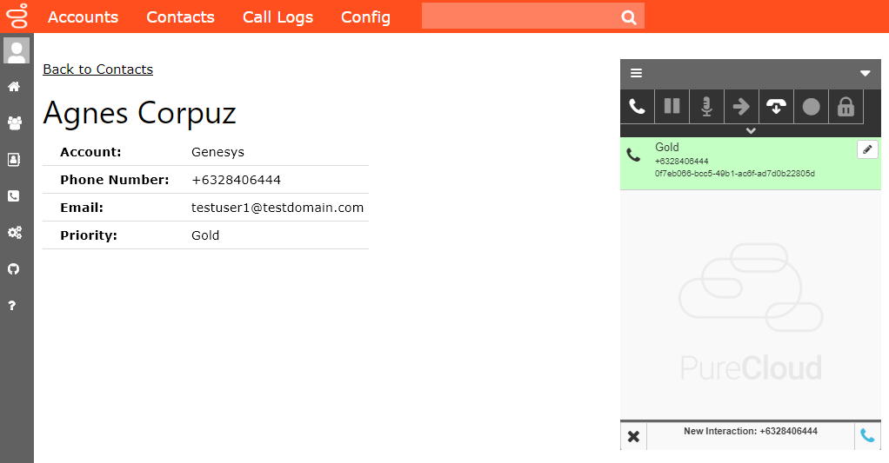

## addCustomAttribute

The Contact page will trigger the addCustomAttribute action of the Embedded Framework. An attribute of PEF_Priority will be added to the interaction ID.

## addAssociation

The Contact page will also trigger the addAssociation action of the Embedded Framework. An association will be added with the caller as the name.

## clickToDial

When the user navigates to the Contacts Page, the app will display a list of all contacts with the name, account, phone, email and priority. Once the user clicks on the phone number, the clickToDial action of the Embedded Framework will be triggered.

## contactSearch

When the user wants to transfer the interaction, the contactSearch method of the Embedded Framework will be triggered and will enable searching contacts by name or queue plus external contacts from the external CRM. In this sample app, the default external contact is set to Weather Line with the phone number +13172222222.

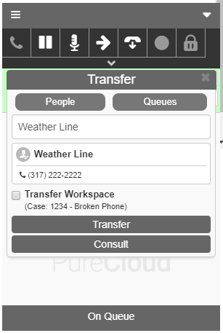

## addTransferContext

When the user wants to transfer the interaction, the addTransferContext method of the Embedded Framework will be triggered. In this example, '(Case: 1234 - Broken Phone)' appears under Transfer Workspace in the Transfer window. When an agent selects Transfer Workspace and transfers the interaction, the integration sends this case with the transferred interaction.



## processCallLog

The processCallLog method will be triggered when there are changes in the call log such as adding an attribute, adding an association or adding notes in the Embedded Framework. In this example, an attribute and an association were added when the incoming call triggered the contact page of the caller. When the user adds a note in the Embedded Framework, the Call Logs page of the sample app will capture the note entered and will display the text under the Notes column.

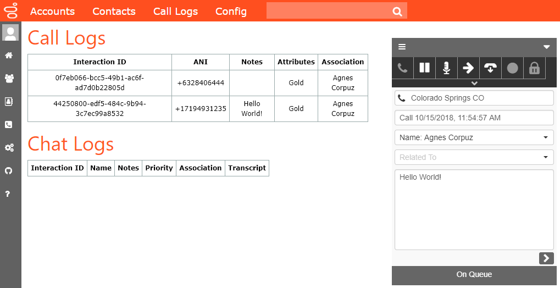

## updateStatus

The user can update their PureCloud status from the app. When the user clicks on the profile button from the sidebar, a list of status will be displayed for the user to choose from. Upon clicking a specific status, the Embedded Framework will trigger the updateStatus method.

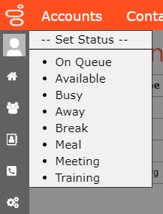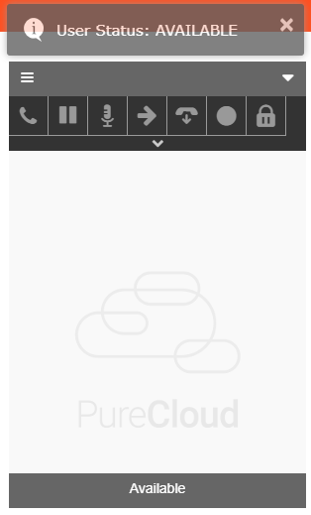

## Subscribe to UserAction type

When the app and the Embedded Framework loads, the app automatically subscribes to the UserAction type of the Embedded Framework. This allows the app to display a toast message when the user updates their PureCloud status.



## getTranscript

When there is a chat interaction, the Chat Logs from the Logs page will display with the Interaction ID, name, notes, priority, association and transcript. Once the chat ends, the user can click on the Transcript column to show the chat transcript. This will trigger the getTranscript method of the Embedded Framework.

